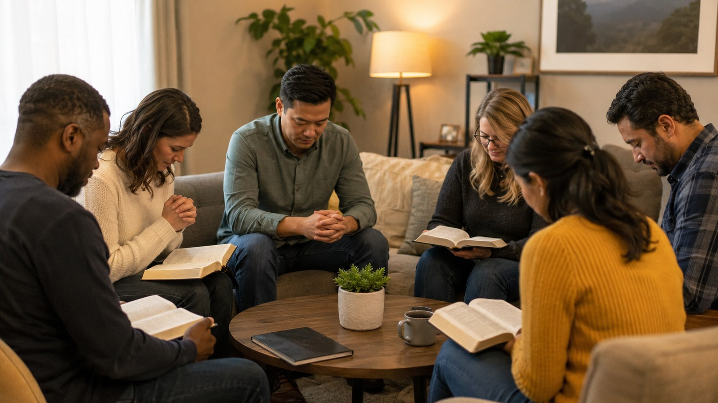
Breathe on Me Breath of God
Small Group Handout • Prayer for Renewal Through the Holy Spirit

Purpose of the Session
This handout guides a small group to study Edwin Hatch's hymn as a prayer for the Holy Spirit to renew the heart, purify the will, kindle divine love, and form believers for holy service.

Hymn at a Glance
Full title | Breathe on Me Breath of God
First line | Breathe on me breath of God
Writer | Edwin Hatch (1835-1889)
Common tune | TRENTHAM — Robert Jackson
Key themes | Worship, Prayer, Faith, Sanctification, Holiness, Mission

Opening Reflection
The hymn begins not with a promise to work harder, but with a prayer: "Breathe on me." Christian renewal starts with the life-giving presence of God. The Spirit gives life, purifies desire, aligns the will, and empowers mission.

Scripture Foundations
- John 20:21-22: The risen Christ breathes on the disciples and says receive the Holy Spirit reflecting the hymn prayer for the renewing breath of God.
- Genesis 2:7: God breathes into humanity the breath of life establishing the biblical foundation for the imagery of divine breath bringing spiritual life.
- Ezekiel 37:5-6: The vision of dry bones coming to life through the breath of God illustrates the renewing power of the Spirit echoed in the hymn.
- Acts 2:1-4: The coming of the Holy Spirit at Pentecost empowers believers for witness and mission corresponding with the hymn prayer for spiritual transformation.
- 2 Corinthians 3:18: Believers are transformed into the image of Christ by the work of the Spirit supporting the hymn theme of inward renewal and sanctification.

Stanza Movement
- Life renewed: The first stanza asks God to fill the believer with new life so that love and obedience reflect God's own desires.
- Heart purified: The second stanza prays for purity and a will aligned with God, not merely external religious activity.
- Love inflamed: The third stanza asks to belong wholly to God, with the earthly self glowing with divine fire.
- Eternal life: The final stanza joins present renewal with the promise of perfect life in God's eternity.

Group Discussion
- What biblical images of breath and life appear in the hymn?
- How does the hymn describe the transforming work of the Holy Spirit?
- Why does spiritual renewal begin with inner change rather than outward activity?
- In what ways can believers cooperate with the Spirit work in their lives?
- How might the church today pray for the renewal expressed in this hymn?

Practice for the Week
- Begin daily prayer by inviting the Holy Spirit to shape thoughts actions and desires according to the character of Christ.
- Reflect regularly on areas of life that need spiritual renewal and surrender them to God in prayer.
- Seek opportunities to serve others as an expression of the Spirit transforming work within the believer.
- Practice spiritual disciplines such as Scripture meditation and worship that nurture attentiveness to the Spirit presence.
- Encourage corporate prayer within the church asking for renewed spiritual vitality and faithful witness.

Closing Prayer
Holy Spirit, breathe new life into us. Purify our desires, align our wills with Christ, fill us with divine love, and make our lives instruments of holy service. Amen.

