Faith of Our Fathers
Sermon Outline: The faith we inherit must become the faith we confess, embody, and pass on.
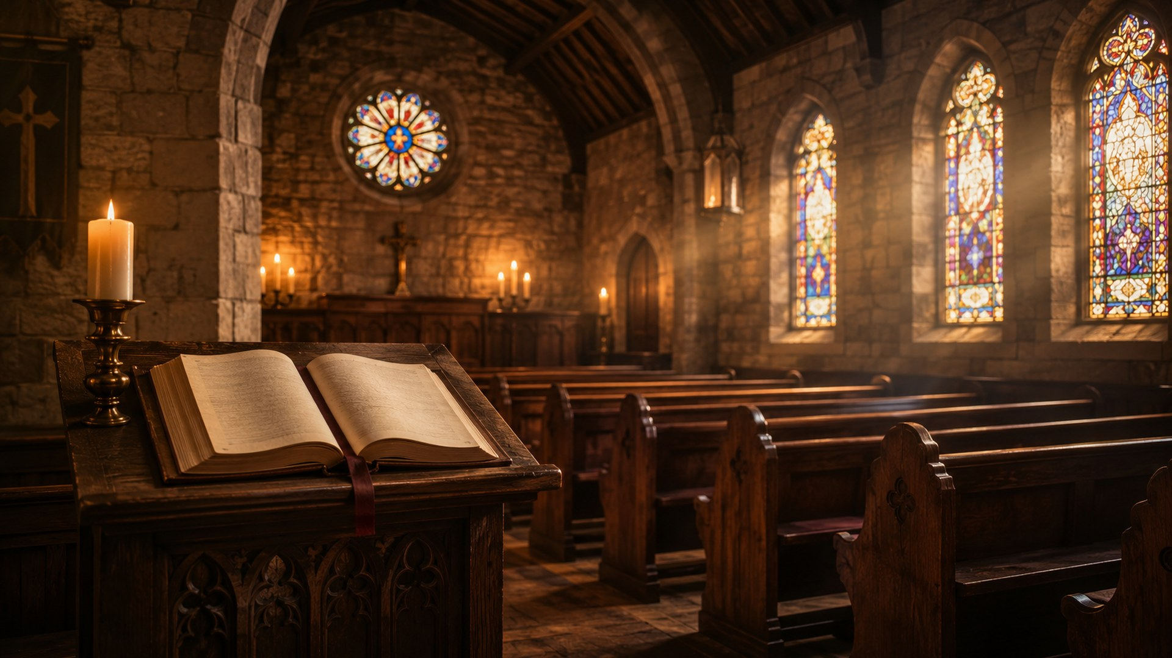
────────────────────────────────────────────────────────────────────────────────

Sermon Summary
Primary text | Hebrews 12:1–2
Supporting texts | Hebrews 11:35–40; 2 Timothy 1:5; Revelation 2:10; Matthew 5:44; Jude 3
Big idea | The faith preserved by faithful witnesses before us must become living faith in us: received with gratitude, confessed with courage, and passed on with love.
Purpose | To call the congregation away from passive nostalgia and toward active, Christ-centered faithfulness.
Pastoral caution | Do not preach the hymn as denominational pride or a Father’s Day hymn. Its subject is inherited Christian faith and costly witness.

Introduction
Suggested opening: Many people inherit songs, customs, and memories, but inherited faith is not the same as living faith. Faith of Our Fathers asks a deeper question: will the faith that survived before us become the faith that lives in us?

Historical setup
Frederick William Faber wrote the hymn in 1849 to honor English Roman Catholics who remained faithful through persecution. Later hymnals adapted the text for wider use. This history helps us preach the hymn with both honesty and charity.

Sermon Movement 1: Faith Received
Text focus: 2 Timothy 1:5; Hebrews 12:1.
- Paul reminds Timothy that sincere faith lived first in Lois and Eunice. Faith can be witnessed, taught, modeled, and passed on.
- Hebrews describes a “great cloud of witnesses.” The church is never the first generation to trust God.
- Application: Name the faithful witnesses who helped form your faith. Receive their testimony with humility, not superiority.
Preaching sentence: We honor the faithful dead best when their faith becomes living obedience in us.

Sermon Movement 2: Faith Tested
Text focus: Hebrews 11:35–40; Revelation 2:10; Matthew 10:32–33.
- The Bible does not romanticize faithfulness. Some believers endured prison, violence, rejection, and death.
- Jesus calls his people to confess him openly, not merely to admire him privately.
- Revelation 2:10 shows that faithful endurance rests on Christ’s promise: “I will give you the crown of life.”
- Application: Ask where fear, comfort, or cultural pressure has made Christian confession weak or silent.
Preaching sentence: Faith that costs nothing may still be untested; faith that clings to Christ under pressure reveals its true center.

Sermon Movement 3: Faith Transmitted in Love
Text focus: Jude 3; Matthew 5:44.
- Jude calls believers to contend for the faith once for all delivered to the saints.
- Jesus commands love for enemies and prayer for persecutors. Courage without love becomes harshness; love without truth becomes compromise.
- The hymn’s final application is not revenge against persecutors but public witness through gracious words and holy life.
- Application: The next generation learns the faith not only by our doctrine but by our speech, courage, mercy, forgiveness, and service.
Preaching sentence: The faith of our fathers becomes the faith of our children only when it becomes visible in our love.

Suggested Illustrations
- A family Bible or old hymnal: valuable not as a museum piece, but as testimony calling for present obedience.
- A relay race: one generation receives the baton, runs faithfully, and passes it forward.
- A prison cell with a free conscience: the hymn’s history reminds us that coercion cannot own the soul that belongs to Christ.

Congregational Applications
- Remember: thank God for faithful witnesses before you.
- Examine: identify where inherited religion has become habit without living trust.
- Confess: speak of Christ with courage where silence has become comfortable.
- Love: pray for opponents, critics, and persecutors without surrendering conviction.
- Transmit: intentionally teach the faith through Scripture, worship, testimony, and example.
Invitation / response
Invite the congregation to pray: “Lord, make the faith we have received living in us. Make us true to Christ in courage, humility, and love until death.”

Closing Prayer
Father, we thank you for the witnesses who have carried the gospel before us. Fix our eyes on Jesus, the author and perfecter of faith. Preserve us from dead tradition, fearful silence, and loveless conviction. Make us faithful in witness, generous in love, and diligent in passing the gospel to the next generation. Amen.

Sources Named in the Attached Data
- The Canterbury Dictionary of Hymnology: Faith of our fathers! living still
- Hymnary.org: Faith of Our Fathers / Faith of our fathers, living still
- Hymnary.org tune entry: ST. CATHERINE (Hemy)
- Frederick William Faber, Jesus and Mary: or, Catholic Hymns for Singing and Reading, 1849
- Discipleship Ministries: History of Hymns, Faith of Our Fathers honors English martyrs
- John Julian, A Dictionary of Hymnology
- Crown of Jesus Music, 1864
- World English Bible, public domain scripture text

